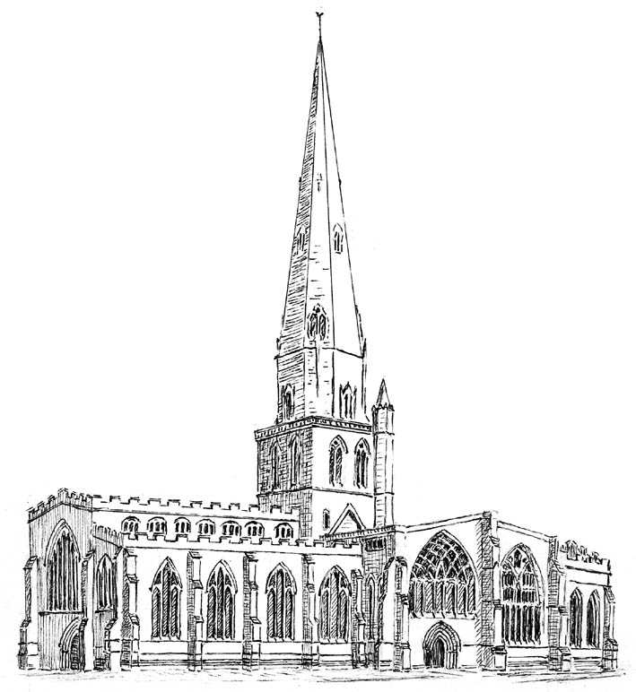 Director of Music
Meadow Cottage
1 Russell Square
Hulland Ward
Ashbourne
DE6 3EA
01335 372064
The Parish Church of St Oswald, Ashbourne mvaehalls@gmail.com

WEDDINGS………………………….
These are a few ideas to help you plan the music for your wedding. When you are ready, please contact me so that we can get together and choose music for your special day.

You need music to walk into and out of church. Many people have
The Bridal Chorus from Lohengrin – R.Wagner and The Wedding March – F.Mendelssohn
but you may prefer one of these or even have ideas of your own.
IN Prince of Denmark’s March – J.Clarke
Trumpet Tune – H. Purcell
OUT Toccata – C.Widor
Hornpipe from the Water Music – G.F.Handel

You can have two or three hymns and/or a psalm included in the service. The following is a list of some possible hymns but there are many other possibilities.

Be thou my vision
Come down O Love Divine
Dear Lord and Father of mankind
Guide me O Thou Great Redeemer
Let there be love shared among us
Lord of all hopefulness
Love divine (There are two tunes.)
Make me a channel of your peace

Morning has broken
Now thank we all our God
O perfect Love
Praise my soul the King of Heaven
Praise the Lord, ye heavens adore him
Psalm 121
Sing Hosanna
The King of Love

There is music while you sign the registers. If you have the choir, then they will sing for you then. These are just a few of the anthems which could be sung. Given the times of some weddings, it may well be impossible for choristers to attend so please advise me well in advance of your wishes.

Ave Maria- Simon Lindley
Brother James Air – Gordon Jacob
Day by Day – Martin How
Gaelic Blessing – John Rutter
Glorious is thy name – Amadeus Mozart

Irish Blessing- Bob Chilcott
Jesu joy of man’s desiring – J.S.Bach
Panis Angelicus – Cesar Franck
Rejoice the Lord is King – Malcolm Archer
The Lord bless you and keep you – John Rutter

I hope this gives you food for thought. All of the above is with St. Oswald’s church in mind. If you are getting married in a different church, you will need to consult the organist there. If you are not sure, please ask. Music will help to make your wedding very special. Nearer the time, it is a good idea to email/show me your order of service so that I can check the detail for you. In the meantime, please do not hesitate to get in touch to help make your wedding day very special. Michael Halls

